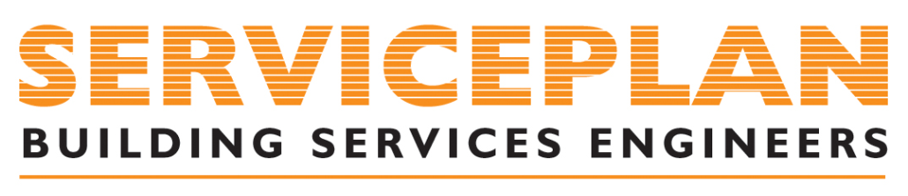

About this Policy

In operating as a successful business, H&V Serviceplan are committed to carrying out all our
business activities in a sustainable manner by pursuing continuous improvement in all aspects
of our business.
As part of our commitment to continuous improvement, customer focus and compliance with
regulatory and statutory requirements, the company’s Quality program is based on the following
principles that identify, manage and evaluate our key business activities, and reduce process,
people, health and safety risk:

Planning
▪ Include quality and continuous improvement considerations in all our decision-making.
▪ Provide adequate support and resources for people at all levels to fulfil their responsibilities.
▪ Implement quality systems, standards and processes to enable all activities to be carried
out in a sustainable manner.
▪ Conduct regular reviews of the company’s performance and implement improvements as
required.
▪ Continuously improve the company’s quality performance.
▪ Continuously improve the company’s Quality System.

Practices
▪ Meet quality standards in the company’s key activities.
▪ Assess the quality impacts of the company’s activities.
▪ Plan, design, and complete all activities in a way that reduces or eliminates risks and
hazards.
▪ Ensure compliance with quality standards, applicable legislation, regulations and codes
of practice.

People
▪ Appoint capable and experienced people to carry out work with a quality focus that aligns
H&V’s Quality Systems, and the requirements of this policy.
▪ Provide opportunities for our people to develop the appropriate knowledge, skills and
behaviours to ensure that every activity or task is carried out with the utmost respect for quality.
▪ Specify the need for contractors to carry out their work in accordance with H&V’s Quality
System and the requirements of this policy, and monitor compliance.
▪ Communicate with relevant key stakeholders about the company’s performance and
critical activities.

